Before you can trouble shoot a computer you need to understand how it boots; about 75% of computer problems happen in the boot process. Here is a simple breakdown how a computer boots.
- When you first turn a computer on the computer goes through what is called the POST (Power on Self Test). The main job of the POST is to(582, Stewart):
- Find and verify main system memory (RAM)
- Initialize all system buses and devices
- Check if the BIOS is present in the system (basic input/output System)
- Identify, organize and select which system devices are available for booting
- Detect weather there is an operations system present to load.
- After the POST is complete the computer looks for the hard drives MBR (Master Boot Record). Once the MBR is located the OS (Operating System) starts to load.
- After the operating system starts to load, it does its own little test. The operating system looks for any installed hardware. Once all the hardware is detected the operating system loads a hardware profile based on the hardware installed in the system.
- Once the hardware profile is loaded the system continues to load the files required to load the operating system GUI (Graphical User Interface).
- Once the computer is finished loading files for the GUI the operating system loads a log on screen which allows the user to input their username and passwords in to the system so they can access files, use the internet or play games.
Basic Hardware Related Booting Problems
With the basic understand of how the computer boots you can tell if there is a problem with the basic hardware. If the computer beeps twice then the memory is not seated in the slots right; if the graphics cards is not pushed down all the way the computer will give a long solid beep. If you do not hear anything coming from the computer and there are no fans spinning inside the case or power supply then there is a good chance the power supply is bad.
Basic Software Related Booting Problems
If the computer pasts the post test and gets to the point where it is about to load the operating system and the computer just reboots then there could be a few problems with the computer.
- There could be a problem with the boot files
- The hard drive could be bad.
If the computer just restarts try reloading just the boot files. If reloading the boot files does not fix the problem then try to run a hard drive disk checking utility to determine if the hard drive is bad or not.
By understanding the boot process it can help a troubleshooter quickly pinpoint the problem with a computer; making their job faster and more efficient.
Visual
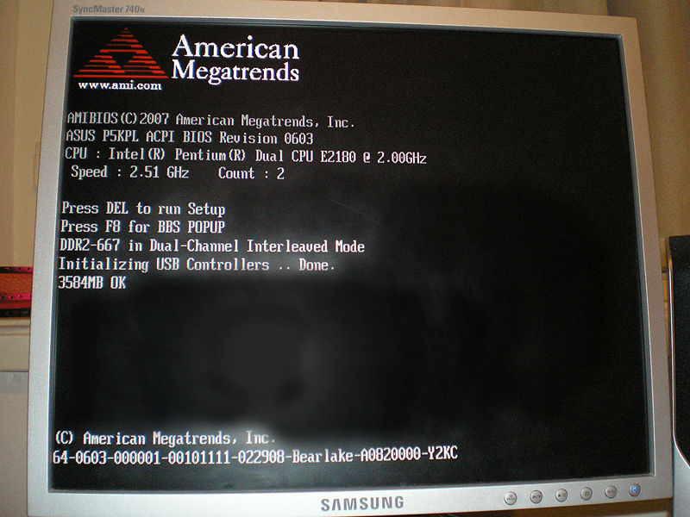

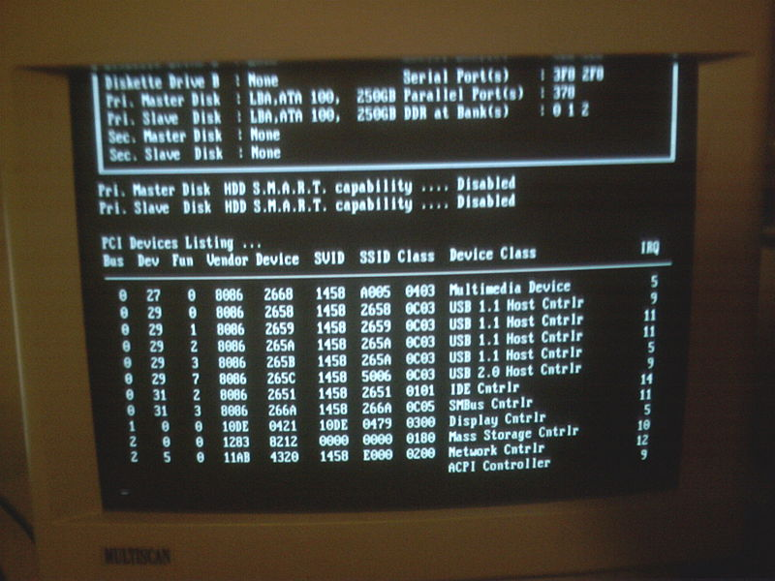

Works Cited

Stewart, James and Ed Tittel. Microsoft Windows XP Professional. Canada: Course Technology, 2006.

